How to apply People Care Credits and Match on the CE PASS
- Click
- Note 
- Click  (This sends us an email so we can credit the account.)
- Go to 
- Enter total amount (check & match) in 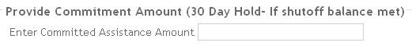
- Note 
- Click

Please make a complete note in both comment boxes that includes what Corp you are from and what check you may be matching . Example: auth $200 match Alma (Corp) to $200 check from Church of God or $300 in people care bill credit Alma (Corp)

